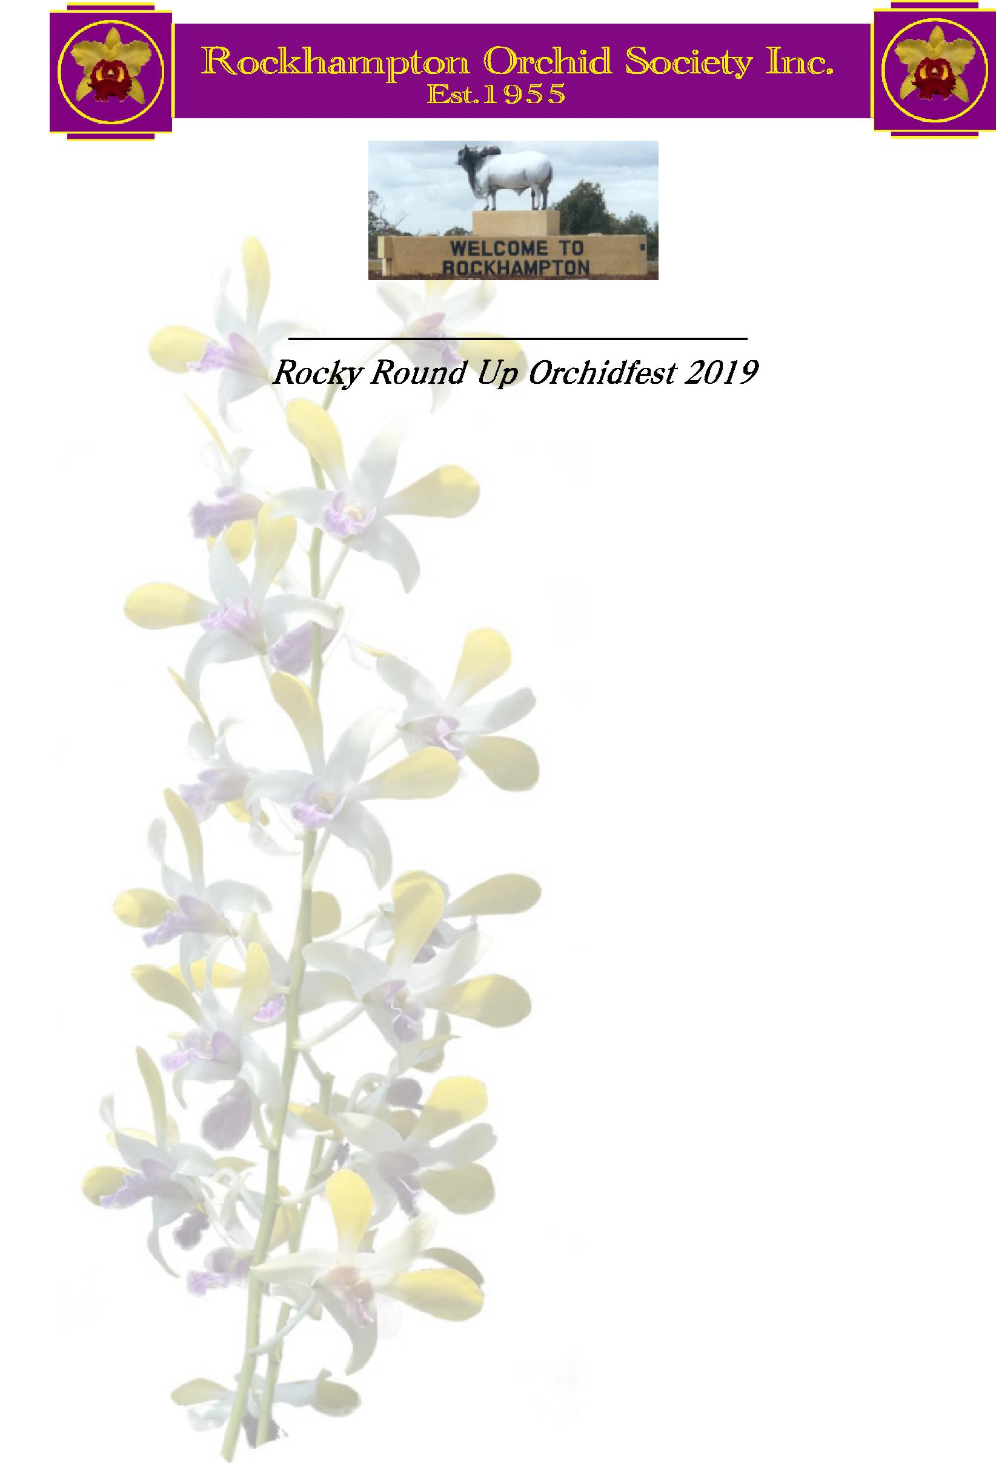

Sub-Tropical Orchid Council Qld. Inc.

Conference and Show 13th -15th Sept

Hosted by

Rockhampton Orchid Society Inc.

Venue

Korte’s Resort

984 Yaamba Road, Parkhurst, North Rockhampton 4701

**Show Schedule**

Please Note: All entries have to be registered by the Barcode/Unique exhibitors code system as now used by most societies affiliated with STOCQ prior to the show

Societies members entries will need to be registered by Wednesday 11th September 2019 and have plant labels printed and attached before entries will be accepted. For exhibitors whose society/club does not use the system, Rockhampton Orchid Society will provide a collator on application to print your plant labels. (Note 3, Page 6) Plants without registered labels cannot be judged.

The Show is open to members of societies and clubs affiliated with

**The Australian Orchid Council.**

Registration satchels available from 9 am Friday 13th Sept. Set up and benching of plants from Noon till 6 pm. At 6 pm a light meal will be provided for judges and their partners, stewards and officials.

**Judging: Friday 13th Sept. From 7 pm. Show open to the public Saturday 14th Sept. 9 am to 4 pm Sunday 15th Sept. 9 am to 3 pm**

President - Jeff Bloxsom 0407 995 122 Show Marshal - Jeff Glover 0409 633 469

**Section Prizes**

Grand Champion $600.00

Reserve Champion $300.00

Best Specimen $200.00

Best Exotic Species (Class 8) $100.00

Best Australian Species (Class 8) $100.00

Class Champions (Classes 1 to 7 & 9) $100.00

Class Sections (1.01 to 9.10) 1st $20.00 – 2nd $10.00 – 3rd $5.00

Club Displays –( 3m X 2m) 1st $300.00 – 2nd $150.00 – 3rd $100.00

Floral Art (Class 10)

Arrangement 1st $40.00 – 2nd $20.00 – 3rd $10.00

Corsage 1st $20.00 – 2nd $10.00 – 3rd $5.00

**(All prizes come with a Rosette or a ribbon plus a prize card)**

**Sections.**

**Class 1 Laeliinae**

1.01 Laeliinae, Standard Shape, over 110mm, predominately white

1.02 Laeliinae, Standard Shape, over 110mm, predominately mauve/pink

1.03 Laeliinae, Standard Shape, over 110mm, predominately yellow/orange

1.04 Laeliinae, Standard Shape, over 110mm, any other colour or combination

1.05 Laeliinae, Standard Shape, 75mm to 110mm, predominately white

1.06 Laeliinae, Standard Shape, 75mm to 110mm, predominately mauve/ pink

1.07 Laeliinae, Standard Shape, 75mm to 110mm, any other colour

1.08 Laeliinae, Standard Shape, under 75mm, any colour

1.09 Laeliinae, Cluster, not less than 5 blooms. (Including Broughtonia influence hybrids and excluding reed stem Epidendrums (Crucifix Orchids)

1.10 Laeliinae, Any other

**Class Champion Laeliinae**

**Class 2 Vandeae**

2.01 Vandeae, Standard shape, blooms over 70mm

2.02 Vandeae, Standard shape, blooms 35mm to 70mm

2.03 Vandeae, Standard shape, blooms under 35mm

2.04 Vandeae, non-standard blooms over 50mm

2.05 Vandeae, non-standard shape, blooms up to 50mm

**Class Champion Vandeae**

**Class 3 Dendrobium**

3.01 Dendrobium, Eugenanthe type (soft cane) predominately white

3.02 Dendrobium, Eugenanthe type (soft cane) Predominately purple/mauve

3.03 Dendrobium, Eugenanthe type (soft cane) any other colour

3.04 Dendrobium, Phalaenanthe or Intermediate type

3.05 Dendrobium, Spatulata type

3.06 Dendrobium, Any other type

**Class Champion Dendrobium**

2

**Class 4 Oncidiinae**

4.01 Oncidiinae, Tolumnia / Zelenkoa type characteristics (ie. Miniature growing)

4.02 Oncidiinae, Gom.(Onc.) varicosum type characteristics (Dominant yellow lip)

4.03 Oncidiinae, Brassia type characteristics. (long, narrow petals)

4.04 Oncidiinae, Any other type not included in the above

**Class Champion Oncidiinae**

**Class 5 Paphiopedilum / Phragmipedium**

5.01 Paphiopedilum, standard complex type

5.02 Paphiopedilum, Maudiae type charactistics

5.03 Paphiopedilum, Brachypetalum / Parvisepalum type charactistics

5.04 Paphiopedilum, Multi-floral type

5.05 Paphiopedilum, Any other type

5.06 Phragmipedium

**Class Champion Paphiopedilum/ Phragmipedium**

**Class 6 Phalaenopsis**

6.01 Phalaenopsis, Standard shape, bloom size over 90mm

6.02 Phalaenopsis, Standard shape, bloom size 60mm to 90mm

6.03 Phalaenopsis, Standard shape, bloom size under 60mm

6.04 Phalaenopsis, any other over 60mm

6.05 Phalaenopsis, any other up to 60mm

**Class Champion Phalaenopsis**

**Class 7 Other Genera**

7.01 Catasetinae

7.02 Epidendrum, reed stem type (crucifix orchid)

7.03 Bulbophyllum hybrid

7.04 Phaius and alliance hybrid

7.05 Zygopetalum and alliance hybrid

7.06 Cymbidium, Standard, Intermediate or Pendulous type

7.07 Cymbidium, any other

7.08 Any other hybrid

**Class Champion any other genera**

**Class 8 Species**

8.01 Laeliinae (Cattleya, Laelia, Sophronitis or Brassavola only.)(**RHS or Sander accepted**)

8.02 Vandae (excluding Phalaenopsis)

8.03 Phalaenopsis

8.04 Dendrobium – Australian

8.05 Dendrobium - Exotic

8.06 Oncidiinae

8.07 Paphiopedilum or Phragmipedium

8.08 Catasetinae

8.09 Any other Australian Species

8.10 Any other Exotic Species

**Best Australian Species and Best Exotic Species**

4

**Class 9 Foliage / Fern**

9.01 Anthurium (var. andreanum or scherzerianum)

9.02 Bromelaid, miniature growth habit (including Cryptanthus)

9.03 Bromelaid in flower

9.04 Bromelaid any other

9.05 Tillandsia small growing type (ie. ionanthe, stricta etc.)

9.06 Tillandsia any other (large growing type)

9.07 Succulent

9.08 Cactus

9.09 Bonsai

9.10 Any other foliage – over 200mm diameter pot size

9.11 Any other foliage – up to 200mm diameter pot size

9.12 Adiantum (Maiden Hair fern)

9.13 Huperzia (Tassel fern)

9.14 Any other fern

**Class Champion Foliage / Fern**

**Class 10 Floral Art**

10.01 Arrangement – using predominately orchid blooms with embellishments

10.02 Corsage – using predominately orchid blooms.

**(Please note: No Class Champion Ribbon in Class 10)**

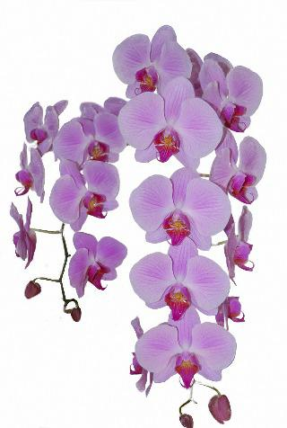

5

**Judging Rules**

1. Entries are free and open to all current financial members of Orchid Societies affiliated with AOC.
2. Requests for display space should be with the Secretary by Sunday 31th March 2019

Plants, displays and floral art may be entered between 12pm and 6pm on Friday 13th September. Judging will commence at 7pm.

**(3**) Plants may be tabled or arranged within a display; however, all orchid and foliage/fern plant names,regardless of whether in a display, tabled or free hanging must be registered in their correct categories as per the schedule by the Barcode/Unique exhibitors code system as now used by most societies affiliated with STOCQ. For exhibitors whose club/society does not use the system, Rockhampton Orchid Society will provide a collator on application, to print your plant labels with a unique number, correct nomenclature, and schedule category as supplied. Plant registration will close on the Wednesday evening prior to the show. At the show the plant name label should be attached as close to the inflorescence as possible either directly to the plant or by means of a suitably unobtrusive support stemming from its pot. Plants not eligible for judging (i.e. not owned for over 6 months etc.) should be clearly marked “Not for Judging”.

**Plants with no name label and unique number will not be judged.**

1. **Displays are to be judged first.** Points allocated - Arrangement & effect 40, Quality 30, Variety 30.Use of a theme in displays is optional but encouraged. No extra points are allocated for themes or name labels. **Display’s club identity must not be disclosed until after all judging completed.**

**(5**) **Show judging shall conform to the judging standards of the Australian Orchid Council.**

* 1. All plants entered shall be owned and grown by the exhibitor for the preceding six months. The Show Marshall in conjunction with senior judges shall have the right to refuse the exhibition of any plant which, in their opinion, appears diseased or pest infected. The Judge/s shall have the power to withhold any prize in any section. **The Judges’ decision is final**
  2. The only flowers other than orchids to be included in displays shall be Bromeliads, Anthuriums, or related types. Foliage and fern must be accessible at the front / sides of displays, or tabled, to enable judging. **Cut blooms are allowed in displays, but are not eligible for judging**. Classes refer to orchid hybrids unless otherwise indicated. Plants are only eligible for judging in one section in a class.

1. A bloom or blooms damaged or broken from an inflorescence in transit to the show will not disqualify that inflorescence, provided the damaged or detached bloom/s is placed on the pot. A bloom/s missing from an inflorescence of a plant that flowers progressively shall not disqualify that inflorescence. Staking and tying for support will be permitted. In all genera, no inflorescence is to be tied or supported on any part of the flower or its attachment to the inflorescence. Parafilm or florists tapes are not allowed as ties.

**(9) Prizes awarded for 1st and 2nd and 3rd in each section.** Class Champions shall be selected from thewinners of each section in that class. **Best Aust. Species** **and** **Best Exotic Species** shall be selected from the species class. **Best Specimen Orchid** shall be selected from all plants exhibited.

1. **Grand Champion** of the show shall be selected from the Class Champions **plus both “Best Species” and “Best Specimen”.**

**The Reserve Champion** of the show shall be selected from the remaining Class Champions, **or Best Species, or Best Specimen,**

1. **The Rockhampton Orchid Society Inc. or its agents will accept no responsibility for theft, loss, destruction or damage to plants or property.**

6